Prior to the training, please download and install R, RStudio, and the packages listed below.

1. Downloading and Installing R

A. Go to http://www.r-project.org; click on the CRAN link on the left hand side of the page.

B. Choose any of the Country/City links; the U.S. sites will likely be faster (I used http://cran.wustl.edu/)

C. Select the link that matches your operating system (Linix, Mac, or Windows).

Windows

D. Choose the base installation.

E. Click on the link for R-4.1.2

F. Select the option to Run the R-4.1.2-win.exe.

MacOS X

D. Click on the link for R-4.1.2.pkg.

E. Select the option to Save File for the R-4.1.2.pkg. Follow the standard installation of the Mac Installer.

2. Downloading RStudio

1. Go to <https://www.rstudio.com/products/rstudio/download/>
2. Choose the Free version

Windows

B. Click on the link for RStudio 2021.09.1+372 - Windows

C. Follow the instillation instructions

MacOS X

B. Click on the link for [RStudio-2021.09.1-372.dmg](https://download1.rstudio.org/desktop/macos/RStudio-2021.09.1-372.dmg)

C. Follow the instillation instructions

After installing both R and RStudio, open RStudio whose screenshot is given here:

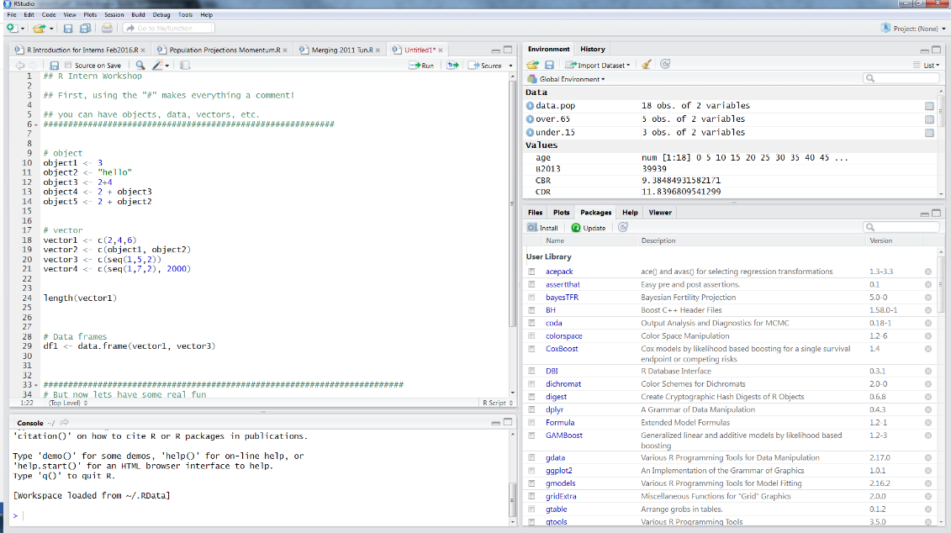

3. Installing Packages

R includes many helpful user written programs called “Packages.” These are not automatically downloaded when we download R and RStudio, but we can easily download them. We download them from inside RStudio- you will need internet access to install these packages.

1. Go to the bottom right square and click on “Packages”

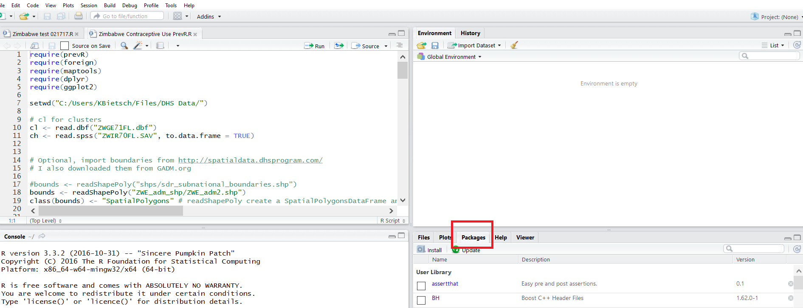

1. Then click “Install”

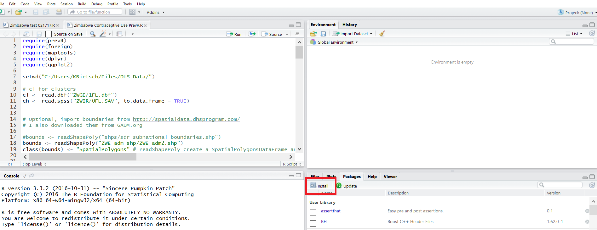

1. A popup box will come up- type the package you want in the line “Packages.”

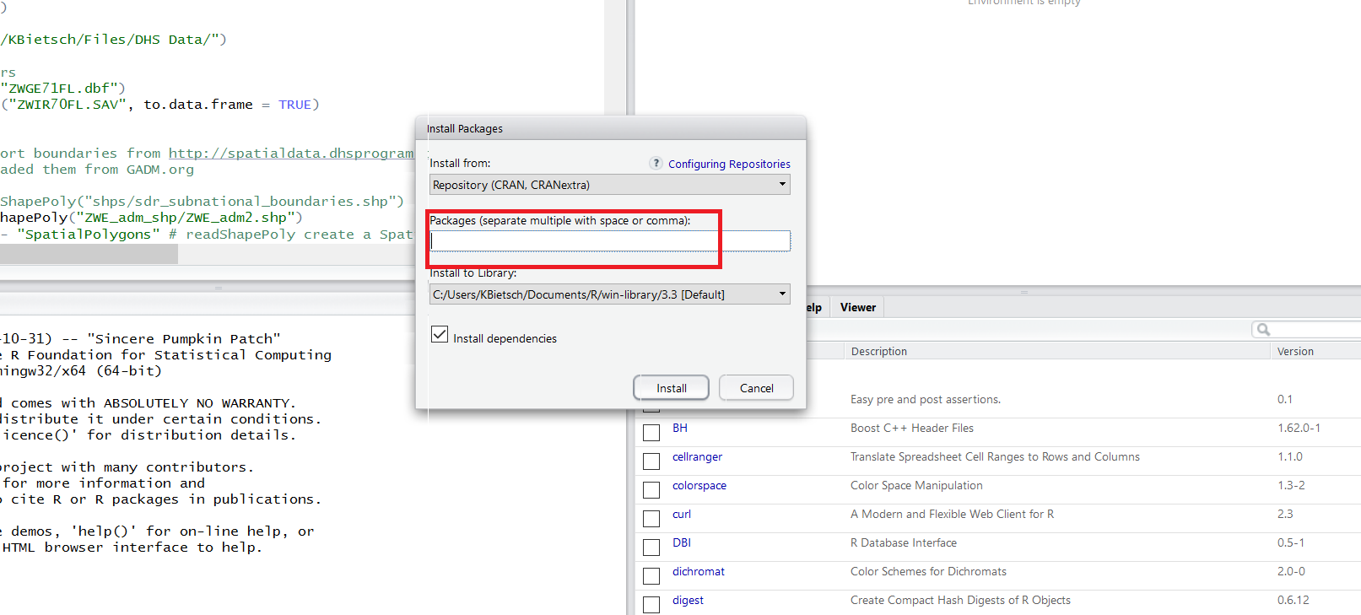

1. Then click “Install”

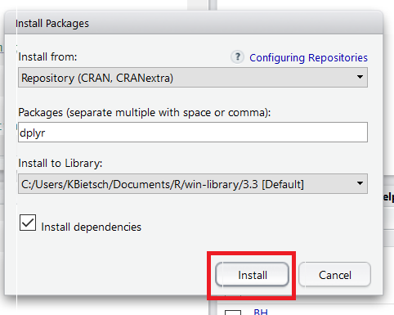

The packages to install before the workshop are:

* tidyverse
* haven
* xlsx
* jsonlite
* data.table
* rsconnect
* shiny
* tabulizer
* staplr
* sjlabelled
* questionr
* survey
* jtools
* foreign
* wbstats
* viridis